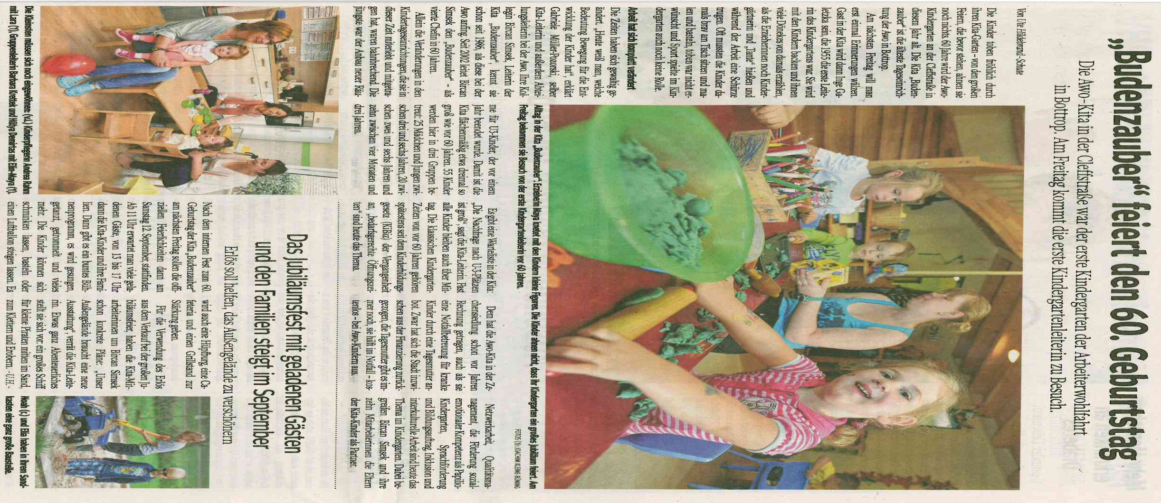
WAZ Bottrop, 12. August 2015

